Chapter 8
Linear Programming: Sensitivity Analysis and Interpretation of Solution

Learning Objectives

1. Understand what happens in graphical solutions when coefficients of the objective function change.

2. Be able to interpret the range for an objective function coefficient.

3. Understand what happens in graphical solutions when right-hand sides change.

4. Be able to interpret the dual price.

5. Be able to interpret the range for a right-hand side.

6. Learn how to formulate, solve and interpret the solution for linear programs with more than two decision variables.

7. Understand the following terms:

sensitivity analysis
dual price
reduced cost
100 percent rule
sunk cost
relevant cost

Solutions:

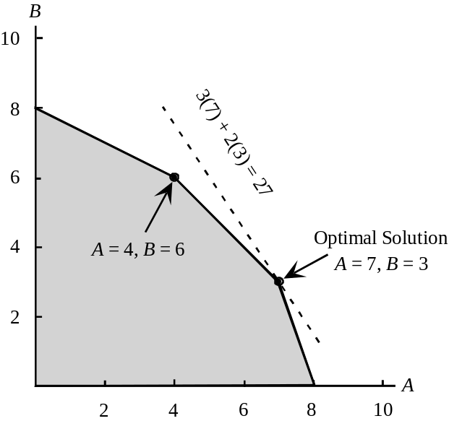1. a.

b. The same extreme point, A = 7 and B = 3, remains optimal.

The value of the objective function becomes 5(7) + 2(3) = 41

c. A new extreme point, A = 4 and B = 6, becomes optimal. The value of the objective function becomes 3(4) + 4(6) = 36.

d. The objective coefficient range for variable A is 2 to 6. Since the change in part (b) is within this range, we know the optimal solution, A = 7 and B = 3, will not change. The objective coefficient range for variable B is 1 to 3. Since the change in part (c) is outside this range, we have to re-solve the problem to find the new optimal solution.

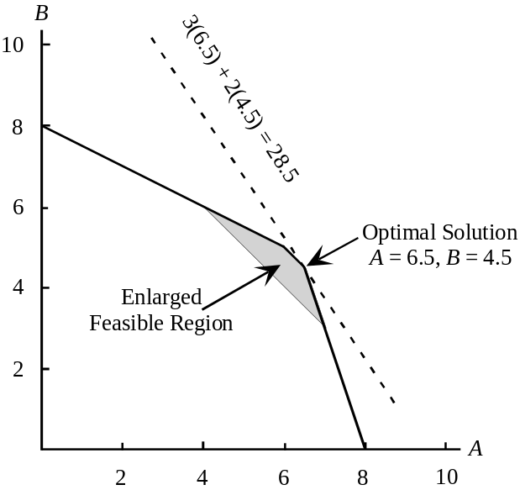2. a.
b. The value of the optimal solution to the revised problem is 3(6.5) + 2(4.5) = 28.5. The one-unit increase in the right-hand side of constraint 1 has improved the value of the optimal solution by 28.5 - 27 = 1.5. Thus, the dual price for constraint 1 is 1.5.

c. The right-hand-side range for constraint 1 is 8 to 11.2. As long as the right-hand side stays within this range, the dual price of 1.5 is applicable.

d. The improvement in the value of the optimal solution will be 0.5 for every unit increase in the right-hand side of constraint 2 as long as the right-hand side is between 18 and 30.

3. a.
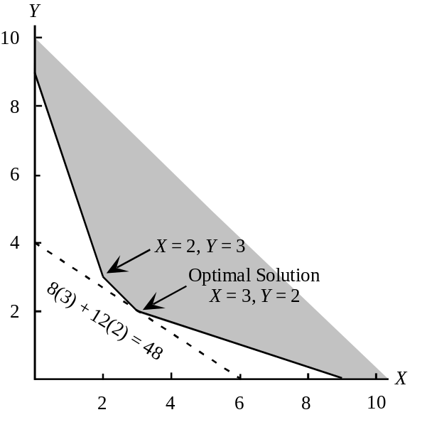

b. The same extreme point, X = 3 and Y = 2, remains optimal.

The value of the objective function becomes 6(3) + 12(2) = 42.

c. A new extreme point, X = 2 and Y = 3, becomes optimal. The value of the objective function becomes 8(2) + 6(3) = 34.

d. The objective coefficient range for variable X is 4 to 12. Since the change in part (b) is within this range, we know that the optimal solution, X = 3 and Y = 2, will not change. The objective coefficient range for variable Y is 8 to 24. Since the change in part (c) is outside this range, we have to re-solve the problem to find the new optimal solution.

4. a.
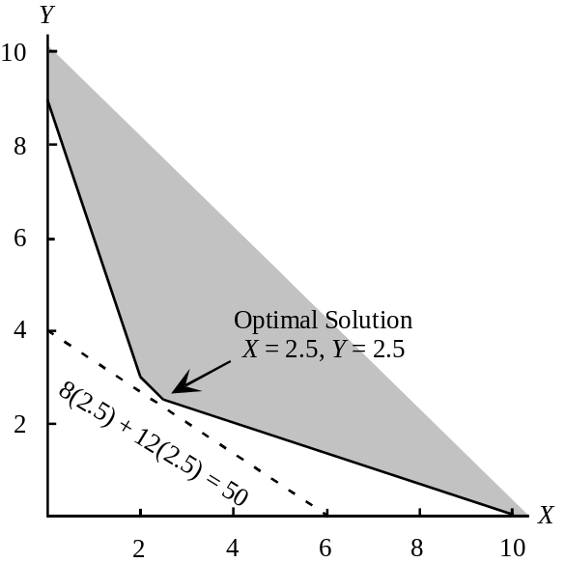

b. The value of the optimal solution to the revised problem is 8(2.5) + 12(2.5) = 50. Compared to the original problem, the value of the optimal solution has increased by 50 - 48 = 2. However, this is a minimization problem and the increase of 2 is not an improvement in the value of the optimal solution. In fact, the value of the optimal solution is worse by 2. Thus, the dual price is -2.

c. The right-hand side range for constraint 1 is 5 to 11. As long as the right-hand side stays within this range, the dual price of -2 is applicable. Since increasing the right-hand side does not improve the value of the optimal solution, decreasing the right-hand side of constraint 1 would b desirable.

d. As long as the right-hand side of constraint 2 is between 9 and 18, a unit increase in the right-hand side will cause the value of the optimal solution to worsen by 3.

5. a. Regular Glove = 500
Catcher’s Mitt = 150
Value = 3700

b. The finishing and packaging and shipping constraints are binding.

c. Cutting and Sewing = 0
Finishing = 3
Packaging and Shipping = 28

Additional finishing time is worth $3 per unit and additional packaging and shipping time is worth $28 per unit.

d. In the packaging and shipping department. Each additional hour is worth $28.

6. a.
Variable | Objective Coefficient Range
Regular Glove | 4 to 12
Catcher’s Mitt | 3.33 to 10

b. As long as the profit contribution for the regular glove is between $4.00 and $12.00, the current solution is optimal.

As long as the profit contribution for the catcher's mitt stays between $3.33 and $10.00, the current solution is optimal.

The optimal solution is not sensitive to small changes in the profit contributions for the gloves.

c. The dual prices for the resources are applicable over the following ranges:

Constraint | Right-Hand-Side Range
Cutting and Sewing | 725 to No Upper Limit
Finishing | 133.33 to 400
Packaging | 75 to 135

d. Amount of increase = (28) (20) = $560

7. a. U = 800
H = 1200
Estimated Annual Return = $8400

b. Constraints 1 and 2. All funds available are being utilized and the maximum permissible risk is being incurred.

c.
Constraint | Dual Prices
Funds Avail. | 0.09
Risk Max | 1.33
U.S. Oil Max | 0

d. No, the optimal solution does not call for investing the maximum amount in U.S. Oil.

8. a. By more than $7.00 per share.

b. By more than $3.50 per share.

- None. This is only a reduction of 100 shares and the allowable decrease is 200.
management may want to address.

9. a. Optimal solution calls for the production of 560 jars of Western Foods Salsa and 240 jars of Mexico City Salsa; profit is $860.

b.
Variable | Objective Coefficient Range
Western Foods Salsa | 0.893 to 1.250
Mexico City Salsa | 1.000 to 1.400

c.
Constraint | Dual Price | Interpretation
1 | 0.125 | One more ounce of whole tomatoes will increase profits by $0.125
2 | 0.000 | Additional ounces of tomato sauce will not improve profits; slack of 160 ounces.
3 | 0.187 | One more ounce of tomato paste will increase profits by $0.187
d.
Constraint | Right-Hand-Side Range
1 | 4320 to 5600
2 | 1920 to No Upper Limit
3 | 1280 to 1640

10. a. S = 4000
M = 10,000
Total risk = 62,000

b.
Variable | Objective Coefficient Range
S | 3.75 to No Upper Limit
M | No Upper Limit to 6.4

c. 5(4000) + 4(10,000) = $60,000

d. 60,000/1,200,000 = 0.05 or 5%

e. 0.057 risk units

f. 0.057(100) = 5.7%

11. a. No change in optimal solution; there is no upper limit for the range of optimality for the objective
coefficient for S.

b. No change in the optimal solution; the objective coefficient for M can increase to 6.4.

c. There is no upper limit on the allowable increase for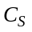; thus the percentage increase is 0%.

For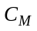, we obtain 0.5/3.4 = 0.147. The accumulated percentage change is 14.7%. Thus, the 100% rule is satisfied and the optimal solution will not change.

12. a. E = 80, S = 120, D = 0

Profit = $16,440

b. Fan motors and cooling coils

c. Labor hours; 320 hours available.

d. Objective function coefficient range of optimality

No lower limit to 159.

Since $150 is in this range, the optimal solution would not change.

13. a. Range of optimality

E 47.5 to 75
S 87 to 126
D No lower limit to 159.

b.
Model | Profit | Change | Allowable Increase/Decrease | %
E | $63 | Increase $6 | $75 - $63 = $12 | 6/12 = 0.50
S | $95 | Decrease $2 | $95 - $87 = $8 | 2/8 = 0.25
D | $135 | Increase $4 | $159 - $135 = $24 | 4/24 = 0.17
 |  |  |  | 0.92

Since changes are 92% of allowable changes, the optimal solution of E = 80, S = 120, D = 0 will not change.

However, the change in total profit will be:

E 80 unit @ + $6 = | $480
S 120 unit @ - $2 = | -240
 | $240
∴ Profit = $16,440 + 240 = 16,680.

c. Range of feasibility

Constraint 1 160 to 180
Constraint 2 200 to 400
Constraint 3 2080 to No Upper Limit

d. Yes, fan motors = 200 + 100 = 300 is outside the range of feasibility.

The dual price will change.

14. a. Manufacture 100 cases of model A
Manufacture 60 cases of model B
Purchase 90 cases of model B
Total Cost = $2170

b. Demand for model A
Demand for model B
Assembly time

c.
Constraint | Dual Price
1 | -12.25
2 | -9.0
3 | 0
4 | .375

If demand for model A increases by 1 unit, total cost will increase by $12.25
If demand for model B increases by 1 unit, total cost will increase by $9.00
If an additional minute of assembly time is available, total cost will decrease by $.375

d. The assembly time constraint. Each additional minute of assembly time will decrease costs by $.375. Note that this will be true up to a value of 1133.33 hours.

Some students may say that the demand constraint for model A should be selected because decreasing the demand by one unit will decrease cost by $12.25. But, carrying this argument to the extreme would argue for a demand of 0.

15. a.
Decision Variable | Ranges of Optimality
AM | No lower limit to 11.75
BM | 3.667 to 9
AP | 12.25 to No Upper Limit
BP | 6 to 11.333

Provided a single change of an objective function coefficient is within its above range, the optimal solution AM = 100, BM = 60, AP = 0, and BP = 90 will not change.
b. This change is within the range of optimality. The optimal solution remains AM = 100, BM = 60, AP = 0, and BP = 90. The $11.20 - $10.00 = $1.20 per unit cost increase will increase the total cost to $2170 = $1.20(100) = $2290.

c.
Variable | Cost | Change | Allowable Increase/Decrease | Percentage  Change
AM | 10 | Increase 1.20 | 11.75 - 10 = 1.75 | (1.20/1.75)100 = 68.57
BM | 6 | Decrease 1 | 6.0 - 3.667 = 2.333 | (1/2.333)100 = 42.86
 |  |  |  | 111.43

111.43% exceeds 100%; therefore, we must resolve the problem.

Resolving the problem provides the new optimal solution: AM = 0, BM = 135, AP = 100, and BP = 15; the total cost is $22,100.

16. a. The optimal solution calls for the production of 100 suits and 150 sport coats. Forty hours of cutting overtime should be scheduled, and no hours of sewing overtime should be scheduled. The total profit is $40,900.

b. The objective coefficient range for suits shows and upper limit of $225. Thus, the optimal solution will not change. But, the value of the optimal solution will increase by ($210-$190)100 = $2000. Thus, the total profit becomes $42,990.

c. The slack for the material coefficient is 0. Because this is a binding constraint, Tucker should consider ordering additional material. The dual price of $34.50 is the maximum extra cost per yard that should be paid. Because the additional handling cost is only $8 per yard, Tucker should order additional material. Note that the dual price of $34.50 is valid up to 1333.33 -1200 = 133.33 additional yards.

d. The dual price of -$35 for the minimum suit requirement constraint tells us that lowering the minimum requirement by 25 suits will improve profit by $35(25) = $875.

17. a. Produce 1000 units of model DRB and 800 units of model DRW

Total profit contribution = $424,000

b. The dual price for constraint 1 (steel available) is 8.80. Thus, each additional pound of steel will increase profit by $8.80. At $2 per pound Deegan should purchase the additional 500 pounds. Note: the upper limit on the right hand side range for constraint 1 is approximately 40,909. Thus, the dual price of $8.80 is applicable for an increase of as much as 909 pounds.

c. Constraint 3 (assembly time) has a slack of 4000 hours. Increasing the number of hours of assembly time is not worthwhile.

d. The objective coefficient range for model DRB shows a lower limit of $112. Thus, the optimal solution will not change; the value of the optimal solution will be $175(1000) + $280(800) = $399,000.

e. An increase of 500 hours or 60(500) = 30,000 minutes will result in 150,000 minutes of manufacturing time being available. Because the upper limit for the right hand side range for the manufacturing time constraint is 160,000 minutes, the dual price of $0.60 per minute will not change.

18. a. The linear programming model is as follows:

Min | 30AN | + | 50AO | + | 25BN | + | 40BO
s.t.
 | AN | + | AO |  |  |  |  | ≥ | 50,000
 |  |  |  |  | BN | + | BO | ≥ | 70,000
 | AN |  |  | + | BN |  |  | ≤ | 80,000
 |  |  | AO |  |  | + | BO | ≤ | 60,000

b. Optimal solution:

 | New Line | Old Line
Model A | 50,000 | 0
Model B | 30,000 | 40,000

Total Cost $3,850,000

c. The first three constraints are binding because the values in the Slack/Surplus column for these constraints are zero. The fourth constraint, with a slack of 0 is nonbinding.

d. The dual price for the new production line capacity constraint is 15. Because the dual price is positive, increasing the right-hand side of constraint 3 will improve the solution. Because the object is to minimize the total production cost, an improvement in the solution corresponds to a reduction in the total production cost. Thus, every one unit increase in the right hand side of this constraint will actually reduce the total production cost by $15. In other words, an increase in capacity for the new production line is desirable.

e. Because constraint 4 is not a binding constraint, any increase in the production line capacity of the old production line will have no effect on the optimal solution. Thus, there is no benefit in increasing the capacity of the old production line.

f. The reduced cost for Model A made on the old production line is 5. Thus, the cost would have to decrease by at least $5 before any units of model A would be produced on the old production line.

g. The right hand side range for constraint 2 shows a lower limit of 30,000. Thus, if the minimum production requirement is reduced 10,000 units to 60,000, the dual price of -40 is applicable. Thus, total cost would decrease by 10,000(40) = $400,000.

19. a. Let P₁ = units of product 1
P₂ = units of product 2
P₃ = units of product 3

Max | 30P₁ | + | 50P₂ | + | 20P₃
s.t. | 0.5P₁ | + | 2P₂ | + | 0.75P₃ | ≤ | 40 | Machine 1
 | P₁ | + | P₂ | + | 0.5P₃ | ≤ | 40 | Machine 2
 | 2P₁ | + | 5P₂ | + | 2P₃ | ≤ | 100 | Labor
 | 0.5P₁ | - | 0.5P₂ | - | 0.5P₃ | ≤ | 0 | Max P₁
 | -0.2P₁ | - | 0.2P₂ | + | 0.8P₃ | ≥ | 0 | Min P₃
P₁, P₂, P₃ ≥ 0

A portion of the optimal solution obtained using The Management Scientist is shown.

Objective Function Value = 1250.000

Variable Value Reduced Costs
-------------- --------------- ------------------
P1 25.000 0.000
P2 0.000 7.500
P3 25.000 0.000
Constraint Slack/Surplus Dual Prices
-------------- --------------- ------------------
1 8.750 0.000
2 2.500 0.000
3 0.000 12.500
4 0.000 10.000
5 15.000 0.000

RIGHT HAND SIDE RANGES

Constraint Lower Limit Current Value Upper Limit
------------ --------------- --------------- ---------------
1 31.250 40.000 No Upper Limit
2 37.500 40.000 No Upper Limit
3 0.000 100.000 106.667
4 -25.000 0.000 5.000
5 No Lower Limit 0.000 15.000

b. Machine Hours Schedule:
Machine 1 31.25 Hours
Machine 2 37.50 Hours

c. $12.50

d. Increase labor hours to 120; the new optimal product mix is

P₁ = 24
P₂ = 8
P₃ = 16
Profit = $1440

20. a. Let H = amount allocated to home loans
P = amount allocated to personal loans
A = amount allocated to automobile loans

Max | 0.07H | + | 0.12P | + | 0.09A
s.t.
 | H | + | P | + | A | = | 1,000,000 | Amount of New Funds
 | 0.6H | - | 0.4P | - | 0.4A | ≥ | 0 | Minimum Home Loans
 |  |  | P | - | 0.6A | ≤ | 0 | Personal Loan Requirement

b. H = $400,000 P = $225,000 A = $375,000
Total annual return = $88,750
Annual percentage return = 8.875%

c. The objective coefficient range for H is No Lower Limit to 0.101. Since 0.09 is within the range, the solution obtained in part (b) will not change.

d. The dual price for constraint 1 is 0.089. The right-hand-side range for constraint 1 is 0 to No Upper Limit. Therefore, increasing the amount of new funds available by $10,000 will increase the total annual return by 0.089 (10,000) = $890.

e. The second constraint now becomes
-0.61H - 0.39P - 0.39A ≥ 0

The new optimal solution is
H = $390,000 P = $228,750 A = $381,250

Total annual return = $89,062.50, an increase of $312.50

Annual percentage return = 8.906%, an increase of approximately 0.031%.

21. a. Let S1 = SuperSaver rentals allocated to room type I
S2 = SuperSaver rentals allocated to room type II
D1 = Deluxe rentals allocated to room type I
D2 = Deluxe rentals allocated to room type II
B1 = Business rentals allocated to room type II

The linear programming formulation and solution is given.

MAX 30S1+20S2+35D1+30D2+40B2

S.T.

1) 1S1+1S2<130
2) 1D1+1D2<60
3) 1B2<50
4) 1S1+1D1<100
5) 1S2+1D2+1B2<120

OPTIMAL SOLUTION

Objective Function Value = 7000.000

Variable Value Reduced Costs
-------------- --------------- ------------------
S1 100.000 0.000
S2 10.000 0.000
D1 0.000 5.000
D2 60.000 0.000
B2 50.000 0.000

Constraint Slack/Surplus Dual Prices
-------------- --------------- ------------------
1 20.000 0.000
2 0.000 10.000
3 0.000 20.000
4 0.000 30.000
5 0.000 20.000

OBJECTIVE COEFFICIENT RANGES

Variable Lower Limit Current Value Upper Limit
------------ --------------- --------------- ---------------
S1 25.000 30.000 No Upper Limit
S2 0.000 20.000 25.000
D1 No Lower Limit 35.000 40.000
D2 25.000 30.000 No Upper Limit
B2 20.000 40.000 No Upper Limit

RIGHT HAND SIDE RANGES

Constraint Lower Limit Current Value Upper Limit
------------ --------------- --------------- ---------------
1 110.000 130.000 No Upper Limit
2 40.000 60.000 70.000
3 30.000 50.000 60.000
4 0.000 100.000 120.000
5 110.000 120.000 140.000

20 SuperSaver rentals will have to be turned away if demands materialize as forecast.

b. RoundTree should accept 110 SuperSaver reservations, 60 Deluxe reservations and 50 Business reservations.

c. Yes, the effect of a person upgrading is an increase in demand for Deluxe accommodations from 60 to 61. From constraint 2, we see that such an increase in demand will increase profit by $10. The added cost of the breakfast is only $5.

d. Convert to a Type I room. From the dual price to constraint 4 we see that this will increase profit by $30.

e. Yes. We would need the forecast of demand for each rental class on the next night. Using the demand forecasts, we would modify the right-hand sides of the first three constraints and resolve.

22. a. Let L = number of hours assigned to Lisa
D = number of hours assigned to David
S = amount allocated to Sarah

Max | 30L | + | 25D | + | 18S
s.t.
 | L | + | D | + | S | = | 100 | Total Time
 | 0.6L | - | 0.4D |  |  | ≥ | 0 | Lisa 40% requirement
 | -0.15L | - | 0.15D | + | 0.85S | ≥ | 0 | Minimum Sarah
 | -0.25L | - | 0.25D | + | S | ≤ | 0 | Maximum Sarah
 | L |  |  |  |  | ≤ | 50 | Maximum Lisa

b. L = 48 hours D = 72 Hours S = 30 Hours
Total Cost = $3780

c. The dual price for constraint 5 is 0. Therefore, additional hours for Lisa will not change the solution.

d. The dual price for constraint 3 is 0. Because there is No Lower Limit on the right-hand-side range, the optimal solution will not change. Resolving the problem without this constraint will also show that the solution obtained in (b) does not change. Constraint 3, therefore, is really a redundant constraint.

23. a. Let C₁ = units of component 1 manufactured
C₂ = units of component 2 manufactured
C₃ = units of component 3 manufactured

Max | 8C₁ | + | 6C₂ | + | 9C₃
s.t. | 6C₁ | + | 4C₂ | + | 4C₃ | ≤ | 7200
 | 4C₁ | + | 5C₂ | + | 2C₃ | ≤ | 6600
 |  |  |  |  | C₃ | ≤ | 200
 | C₁ |  |  |  |  | ≤ | 1000
 |  |  | C₂ |  |  | ≤ | 1000
 | C₁ |  |  |  |  | ≥ | 600
C₁, C₂, C₃ ≥ 0

The optimal solution is

C₁ = 600
C₂ = 700
C₃ = 200

b.
Variable | Objective Coefficient Range
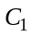 | No Lower Limit to 9.0
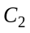 | 5.33 to 9.0
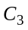 | 6.00 to No Lower Limit
Individual changes in the profit coefficients within these ranges will not cause a change in the optimal number of components to produce.

Constraint | Right-Hand-Side Range
1 | 4400 to 7440
2 | 6300 to No Upper Limit
3 | 100 to 900
4 | 600 to No Upper Limit
5 | 700 to No Upper Limit
6 | 514.29 to 1000

These are the ranges over which the dual prices for the associated constraints are applicable.

d. Nothing, since there are 300 minutes of slack time on the grinder at the optimal solution.

e. No, since at that price it would not be profitable to produce any of component 3.

24. Let A = number of shares of stock A
B = number of shares of stock B
C = number of shares of stock C
D = number of shares of stock D

a. To get data on a per share basis multiply price by rate of return or risk measure value.

Min | 10A | + | 3.5B | + | 4C | + | 3.2D
s.t.
 | 100A | + | 50B | + | 80C | + | 40D | = | 200,000
 | 12A | + | 4B | + | 4.8C | + | 4D | ≥ | 18,000 | (9% of 200,00)
 | 100A |  |  |  |  |  |  | ≤ | 100,000
 |  |  | 50B |  |  |  |  | ≤ | 100,000
 |  |  |  |  | 80C |  |  | ≤ | 100,000
 |  |  |  |  |  |  | 40D | ≤ | 100,000
A, B, C, D ≥ 0

Solution: A = 333.3, B = 0, C = 833.3, D = 2500
Risk: 14,666.7
Return: 18,000 (9%) from constraint 2

b.
Max | 12A | + | 4B | + | 4.8C | + | 4D
s.t.
 | 100A | + | 50B | + | 80C | + | 40D | = | 200,000
 | 100A |  |  |  |  |  |  | ≤ | 100,000
 |  |  | 50B |  |  |  |  | ≤ | 100,000
 |  |  |  |  | 80C |  |  | ≤ | 100,000
 |  |  |  |  |  |  | 40D | ≤ | 100,000
A, B, C, D ≥ 0

Solution: A = 1000, B = 0, C = 0, D = 2500
Risk: 10A + 3.5B + 4C + 3.2D = 18,000
Return: 22,000 (11%)

c. The return in part (b) is $4,000 or 2% greater, but the risk index has increased by 3,333.

Obtaining a reasonable return with a lower risk is a preferred strategy in many financial firms. The more speculative, higher return investments are not always preferred because of their associated higher risk.

25. a. Let O1 = percentage of Oak cabinets assigned to cabinetmaker 1
O2 = percentage of Oak cabinets assigned to cabinetmaker 2
O3 = percentage of Oak cabinets assigned to cabinetmaker 3
C1 = percentage of Cherry cabinets assigned to cabinetmaker 1
C2 = percentage of Cherry cabinets assigned to cabinetmaker 2
C3 = percentage of Cherry cabinets assigned to cabinetmaker 3

Min | 1800 O1 | + | 1764 O2 | + | 1650 O3 | + | 2160 C1 | + | 2016 C2 | + | 1925 C3
s.t.
 | 50 O1 |  |  |  |  | + | 60 C1 |  |  |  |  | ≤ | 40 | Hours avail. 1
 |  |  | 42O2 |  |  |  |  | + | 48 C2 |  |  | ≤ | 30 | Hours avail. 2
 |  |  |  |  | 30 O3 |  |  |  |  | + | 35 C3 | ≤ | 35 | Hours avail. 3
 | O1 | + | O2 | + | O3 |  |  |  |  |  |  | = | 1 | Oak
 |  |  |  |  |  |  | C1 | + | C2 | + | C3 | = | 1 | Cherry
O1, O2, O3, C1, C2, C3 ≥ 0

Note: objective function coefficients are obtained by multiplying the hours required to complete all the oak or cherry cabinets times the corresponding cost per hour. For example, 1800 for O1 is the product of 50 and 36, 1764 for O2 is the product of 42 and 42 and so on.
b.
 | Cabinetmaker 1 | Cabinetmaker 2 | Cabinetmaker 3
Oak | O1 = 0.271 | O2 = 0.000 | O3 = 0.729
Cherry | C1 = 0.000 | C2 = 0.625 | C3 = 0.375

Total Cost = $3672.50

c. No, since cabinetmaker 1 has a slack of 26.458 hours. Alternatively, since the dual price for constraint 1 is 0, increasing the right hand side of constraint 1 will not change the value of the optimal solution.

d. The dual price for constraint 2 is 1.750. The upper limit on the right-hand-side range is 41.143. Therefore, each additional hour of time for cabinetmaker 2 will reduce total cost by $1.75 per hour, up to a maximum of 41.143 hours.

e. The new objective function coefficients for O2 and C2 are 42(38) = 1596 and 48(38) = 1824, respectively. The optimal solution does not change but the total cost decreases to $3552.50.

26. a. Let M₁ = units of component 1 manufactured
M₂ = units of component 2 manufactured
M₃ = units of component 3 manufactured
P₁ = units of component 1 purchased
P₂ = units of component 2 purchased
P₃ = units of component 3 purchased

Min | 4.50 M₁ |  | 5.00M₂ |  | 2.75M₃ |  | 6.50P₁ |  | 8.80P₂ |  | 7.00P₃
s.t. | 2M₁ |  | 3M₂ |  | 4M₃ |  |  |  |  |  |  | ≤ | 21,600 | Production
 | 1M₁ |  | 1.5M₂ |  | 3M₃ |  |  |  |  |  |  | ≤ | 15,000 | Assembly
 | 1.5M₁ |  | 2M₂ |  | 5M₃ |  |  |  |  |  |  | ≤ | 18,000 | Testing/Packaging
 | M₁ |  |  |  |  |  | 1P₁ |  |  |  |  | = | 6,000 | Component 1
 |  |  | 1M₂ |  |  |  |  |  | 1P₂ |  |  | = | 4,000 | Component 2
 |  |  |  |  | 1M₃ |  |  |  |  |  | 1P₃ | = | 3,500 | Component 3
M₁, M₂, M₃, P₁, P₂, P₃ ≥ 0

b.
Source | Component 1 | Component 2 | Component 3
Manufacture | 2000 | 4000 | 1400
Purchase | 4000 | 0 | 2100

Total Cost: $73,550

c. Since the slack is 0 in the production and the testing & packaging departments, these department are limiting Benson's manufacturing quantities.

Dual prices information:
Production $0.906/minute x 60 minutes = $54.36 per hour
Testing/Packaging $0.125/minute x 60 minutes = $ 7.50 per hour

d. The dual price is -$7.969. this tells us that the value of the optimal solution will worsen (the cost will increase) by $7.969 for an additional unit of component 2. Note that although component 2 has a purchase cost per unit of $8.80, it would only cost Benson $7.969 to obtain an additional unit of component 2.

27. Let RS = number of regular flex shafts made in San Diego
RT = number of regular flex shafts made in Tampa
SS = number of stiff flex shafts made in San Diego
ST = number of shift flex shafts made in Tampa

Min | 5.25 RS | + | 4.95 RT | + | 5.40 SS | + | 5.70 ST
s.t.
 | RS | + |  |  | SS |  |  | ≤ | 120,000
 |  |  | RT | + |  |  | ST | ≤ | 180,000
 | RS | + | RT |  |  |  |  | = | 200,000
 |  |  |  |  | SS | + | ST | = | 75,000
RS, RT, SS, ST ≥ 0

OPTIMAL SOLUTION

Objective Function Value = 1401000.000

Variable Value Reduced Costs
-------------- --------------- ------------------
RS 20000.000 0.000
ST 180000.000 0.000
SS 75000.000 0.000
ST 0.000 0.600

Constraint Slack/Surplus Dual Prices
-------------- --------------- ------------------
1 25000.000 0.000
2 0.000 0.300
3 0.000 -5.250
4 0.000 -5.40

OBJECTIVE COEFFICIENT RANGES

Variable Lower Limit Current Value Upper Limit
------------ --------------- --------------- ---------------
RS 4.950 5.250 No Upper Limit
ST No Lower Limit 4.950 5.250
SS No Lower Limit 5.400 6.000
ST 5.100 5.700 No Upper Limit

RIGHT HAND SIDE RANGES

Constraint Lower Limit Current Value Upper Limit
------------ --------------- --------------- ---------------
1 95000.000 120000.000 No Upper Limit
2 155000.000 180000.000 200000.000
3 180000.000 200000.000 225000.000
4 0.000 75000.000 100000.000

28. a. Let G = amount invested in growth stock fund
S = amount invested in income stock fund
M = amount invested in money market fund

Max | 0.20G | + | 0.10S | + | 0.06M
s.t.
 | 0.10G | + | 0.05S | + | 0.01M | ≤ | (0.05)(300,000) | Hartmann's max risk
 | G |  |  |  |  | ≥ | (0.10)(300,000) | Growth fund min.
 |  |  | S |  |  | ≥ | (0.10)(300,000) | Income fund min.
 |  |  |  |  | M | ≥ | (0.20)(300,000) | Money market min,
 | G | + | S | + | M | ≤ | 300,000 | Funds available

G, S, M ≥ 0

b. The solution to Hartmann's portfolio mix problem is given.

Objective Function Value = 36000.000

Variable Value Reduced Costs
-------------- --------------- ------------------
G 120000.000 0.000
S 30000.000 0.000
M 150000.000 0.000

Constraint Slack/Surplus Dual Prices
-------------- --------------- ------------------
1 0.000 1.556
2 90000.000 0.000
3 0.000 -0.022
4 90000.000 0.000
5 0.000 0.044

OBJECTIVE COEFFICIENT RANGES

Variable Lower Limit Current Value Upper Limit
------------ --------------- --------------- ---------------
G 0.150 0.200 0.600
S No Lower Limit 0.100 0.122
M 0.020 0.060 0.200

RIGHT HAND SIDE RANGES

Constraint Lower Limit Current Value Upper Limit
------------ --------------- --------------- ---------------
1 6900.000 15000.000 23100.000
2 No Lower Limit 30000.000 120000.000
3 0.000 30000.000 192000.016
4 No Lower Limit 60000.000 150000.000
5 219000.000 300000.000 1110000.500

c. These are given by the objective coefficient ranges. The portfolio above will be optimal as long as the yields remain in the following intervals:

Growth stock 0.15 ≤ c₁ ≤ 0.60
Income stock No Lower Limit < c₂ ≤ 0.122
Money Market 0.02 ≤ c₃ ≤ 0.20

d. The dual price for the first constraint provides this information. A change in the risk index from 0.05 to 0.06 would increase the constraint RHS by 3000 (from 15,000 to 18,000). This is within the right-hand-side range, so the dual price of 1.556 is applicable. The value of the optimal solution would increase by (3000)(1.556) = 4668.

Hartmann's yield with a risk index of 0.05 is

36,000 / 300,000 = 0.12
His yield with a risk index of 0.06 would be

40,668 / 300,000 = 0.1356

e. This change is outside the objective coefficient range so we must re-solve the problem. The solution is shown below.

LINEAR PROGRAMMING PROBLEM

MAX .1G + .1S + .06M

S.T.

1) .1G + .05S + .01M < 15000
2) G > 30000
3) S > 30000
4) M > 60000
5) G + S + M < 300000

OPTIMAL SOLUTION

Objective Function Value = 27600.000

Variable Value Reduced Costs
-------------- --------------- ------------------
G 48000.000 0.000
S 192000.000 0.000
M 60000.000 0.000

Constraint Slack/Surplus Dual Prices
-------------- --------------- ------------------
1 0.000 0.000
2 18000.000 0.000
3 162000.000 0.000
4 0.000 -0.040
5 0.000 0.100

OBJECTIVE COEFFICIENT RANGES

Variable Lower Limit Current Value Upper Limit
------------ --------------- --------------- ---------------
G 0.100 0.100 0.150
S 0.078 0.100 0.100
M No Lower Limit 0.060 0.100

RIGHT HAND SIDE RANGES

Constraint Lower Limit Current Value Upper Limit
------------ --------------- --------------- ---------------
1 14100.000 15000.000 23100.000
2 No Lower Limit 30000.000 48000.000
3 No Lower Limit 30000.000 192000.000
4 37500.000 60000.000 150000.000
5 219000.000 300000.000 318000.000

f. The client's risk index and the amount of funds available.

g. With the new yield estimates, Pfeiffer would solve a new linear program to find the optimal portfolio mix for each client. Then by summing across all 50 clients he would determine the total amount that should be placed in a growth fund, an income fund, and a money market fund. Pfeiffer then would make the necessary switches to have the correct total amount in each account. There would be no actual switching of funds for individual clients.

29. a. Relevant cost since LaJolla Beverage Products can purchase wine and fruit juice on an as - needed basis.

b. Let W = gallons of white wine
R = gallons of rose wine
F = gallons of fruit juice

Max | 1.5 W | + | 1R | + | 2F
s.t.
 | 0.5W | - | 0.5R | - | 0.5F | ≥ | 0 | % white
 | -0.2W | + | 0.8R | - | 0.2F | ≥ | 0 | % rose minimum
 | -0.3W | + | 0.7R | - | 0.3F | ≤ | 0 | % rose maximum
 | -0.2W | - | 0.2R | + | 0.8F | = | 0 | % fruit juice
 | W |  |  |  |  | ≤ | 10000 | Available white
 |  |  | R |  |  | ≤ | 8000 | Available rose
W, R, F ≥ 0

Optimal Solution: W = 10,000, R = 6000, F = 4000
profit contribution = $29,000.

c. Since the cost of the wine is a relevant cost, the dual price of $2.90 is the maximum premium (over the normal price of $1.00) that LaJolla Beverage Products should be willing to pay to obtain one additional gallon of white wine. In other words, at a price of $3.90 = $2.90 + $1.00, the additional cost is exactly equal to the additional revenue.

d. No; only 6000 gallons of the rose are currently being used.

e. Requiring 50% plus one gallon of white wine would reduce profit by $2.40. Note to instructor: Although this explanation is technically correct, it does not provide an explanation that is especially useful in the context of the problem. Alternatively, we find it useful to explore the question of what would happen if the white wine requirement were changed to at least 51%. Note that in this case, the first constraint would change to 0.49W - 0.51R - 0.51F ≥ 0. This shows the student that the coefficients on the left-hand side are changing; note that this is beyond the scope of sensitivity analysis discussed in this chapter. Resolving the problem with this revised constraint will show the effect on profit of a 1% change.

f. Allowing the amount of fruit juice to exceed 20% by one gallon will increase profit by $1.00.

30. a. Let L = minutes devoted to local news
N = minutes devoted to national news
W = minutes devoted to weather
S = minutes devoted to sports

Min | 300L | + | 200N | + | 100W | + | 100S
s.t.
 | L | + | N | + | W | + | S | = | 20 | Time available
 | L |  |  |  |  |  |  | ≥ | 3 | 15% local
 | L | + | N |  |  |  |  | ≥ | 10 | 50% requirement
 |  |  |  |  | W | - | S | ≤ | 0 | Weather - sports
 | -L | - | N |  |  | + | S | ≤ | 0 | Sports requirement
 |  |  |  |  | W |  |  | ≥ | 4 | 20% weather
L, N, W, S ≥ 0

Optimal Solution: L = 3, N = 7, W = 5, S = 5
Total cost = $3,300

b. Each additional minute of broadcast time increases cost by $100; conversely, each minute reduced will decrease cost by $100. These interpretations are valid for increase up to 10 minutes and decreases up to 2 minutes from the current level of 20 minutes.

c. If local coverage is increased by 1 minute, total cost will increase by $100.

d. If the time devoted to local and national news is increased by 1 minute, total cost will increase by $100.

e. Increasing the sports by one minute will have no effect for this constraint since the dual price is 0.

31. a. Let B = number of copies done by Benson Printing
J = number of copies done by Johnson Printing
L = number of copies done by Lakeside Litho

Min | 2.45B | + | 2.5J | + | 2.75L
s.t.
 | B |  |  |  |  | ≤ | 30,000 | Benson
 |  |  | J |  |  | ≤ | 50,000 | Johnson
 |  |  |  |  | L | ≤ | 50,000 | Lakeside
 | 0.9B | + | 0.99J | + | 0.995L | = | 75,000 | # useful reports
 | B | - | 0.1J |  |  | ≥ | 0 | Benson - Johnson %
 |  |  |  |  | L | ≥ | 30,000 | Minimum Lakeside
B, J, L ≥ 0

Optimal Solution: B = 4,181, J = 41,806, L = 30,000
b. Suppose that Benson printing has a defective rate of 2% instead of 10%. The new optimal solution would increase the copies assigned to Benson printing to 30,000. In this case, the additional copies assigned to Benson Printing would reduce on a one-for-one basis the number assigned to Johnson Printing.

c. If the Lakeside Litho requirement is reduced by 1 unit, total cost will decrease by $0.2210.

32. a. Let P₁ = number of PT-100 battery packs produced at the Philippines plant
P₂ = number of PT-200 battery packs produced at the Philippines plant
P₃ = number of PT-300 battery packs produced at the Philippines plant
M₁ = number of PT-100 battery packs produced at the Mexico plant
M₂ = number of PT-200 battery packs produced at the Mexico plant
M₃ = number of PT-300 battery packs produced at the Mexico plant

Total production and shipping costs ($/unit)

 | Philippines | Mexico
PT-100 | 1.13 | 1.08
PT-200 | 1.16 | 1.16
PT-300 | 1.52 | 1.25

Min | 1.13P₁ | + | 1.16P₂ | + | 1.52P₃ | + | 1.08M₁ | + | 1.16M₂ | + | 1.25M₃
s.t.
 | P₁ | + |  |  |  |  | M₁ |  |  |  |  | = | 200,000
 |  |  | P₂ | + |  |  |  |  | M₂ |  |  | = | 100,000
 |  |  |  |  | P₃ | + |  |  |  |  | M₃ | = | 150,000
 | P₁ | + | P₂ |  |  |  |  |  |  |  |  | ≤ | 175,000
 |  |  |  |  |  |  | M₁ | + | M₂ |  |  | ≤ | 160,000
 |  |  |  |  | P₃ |  |  |  |  |  |  | ≤ | 75,000
 |  |  |  |  |  |  |  |  |  |  | M₃ | ≤ | 100,000
P₁, P₂, P₃, M₁, M₂, M₃ ≥ 0

b. The optimal solution is as follows:

 | Philippines | Mexico
PT-100 | 40,000 | 160,000
PT-200 | 100,000 | 0
PT-300 | 50,000 | 100,000

The total production and transportation cost is $535,000.

c. The range of optimality for the objective function coefficient for P₁ shows a lower limit of $1.08. Thus, the production and/or shipping cost would have to decrease by at least 5 cents per unit.

d. The range of optimality for the objective function coefficient for M₂ shows a lower limit of $1.11. Thus, the production and/or shipping cost could have to decrease by at least 5 cents per unit.

