Harper’s Math 230 Minitab Handout – Chapters 8 & beyond

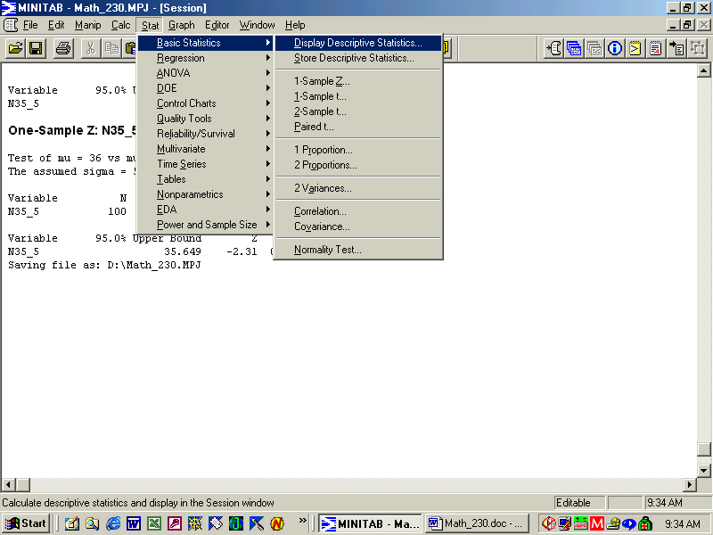

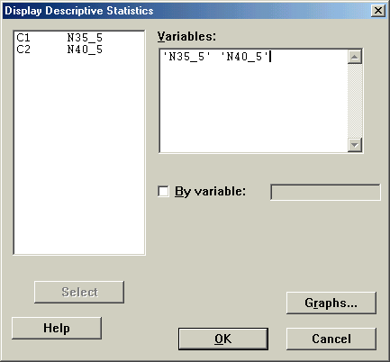

Descriptive Statistics: N35_5, N40_5

Variable N Mean Median TrMean StDev SE Mean
N35_5 100 34.775 34.700 34.684 5.314 0.531
N40_5 100 39.940 40.200 39.942 4.981 0.498

Variable Minimum Maximum Q1 Q3
N35_5 16.925 52.106 31.551 38.225
N40_5 22.079 54.407 36.142 42.901

Harper note: Notice that n = 100 implying the large sample size approach in MBB (Mendenhall, Beaver, Beaver) chapters 8 & 9 is applicable in which sample sizes of >= 30 are assumed.

In what immediately follows below is based on Chapters 8 & 9 (large samples) - doing confidence intervals and one-sample z tests for large samples.

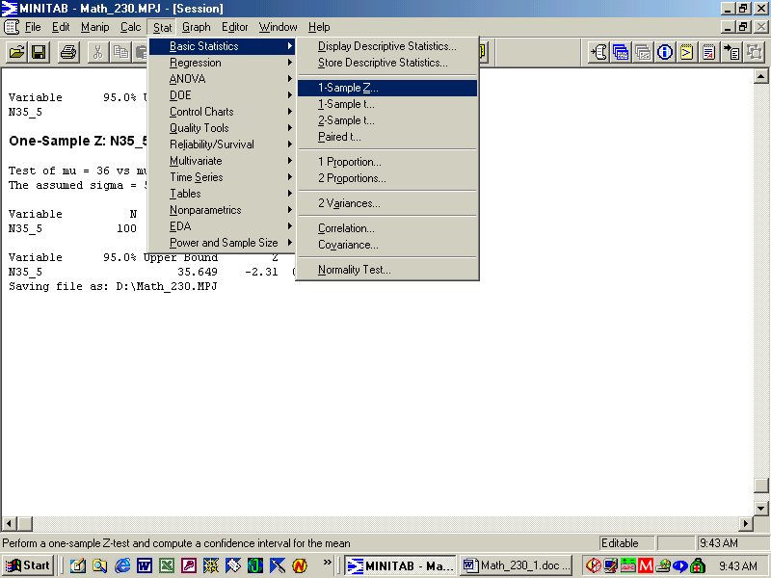

Harper note: The way Minitab knows whether it is a 1 or 2 tailed (often called 1 or 2 sided) is in the setting the options. If the alternative is set to “not equal”, then it is a 2 tailed test or confidence interval. Selecting “less than” or “greater than” in the options changes it from the default 2 tailed test to a 1 tailed test with all of alpha put into one of the tails (the tail that matches the alternative hypothesis). Alpha is used to define the “critical region” that leads to rejection of the null hypothesis in favor of the alternative.

The p-value (P in printout) is a quick way to tell whether to reject the null hypotheses H₀ in favor of the alternative hypothesis H_{a} if it is given.
If the p-value < alpha, reject H₀ ; otherwise do not reject H₀ . For this class, you may say not rejecting H₀ is the same as accepting H₀ (though this wording is not liked by statisticians including moi).
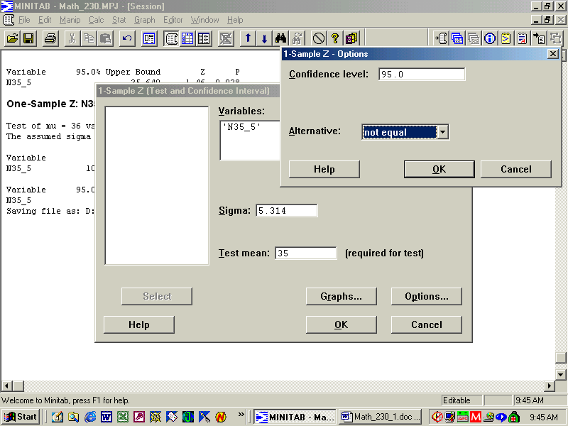

One-Sample Z: N35_5
Harper note: This is a test of the null hypothesis 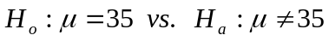 Title above tells you it is a one sample z test (i.e., assumes sigma is known).

Test of mu = 35 vs mu not = 35
The assumed sigma = 5.314
Variable N Mean StDev SE Mean
N35_5 100 34.775 5.314 0.531
Variable 95.0% CI Z P
N35_5 ( 33.733, 35.816) -0.42 0.672

Harper note: Note that alpha = = 0.05 (or 5%) since the confidence level is 95%. Since this is a two sided (or two tailed test), alpha/2 (=.05/2 = .025) is put into each tail. Since it is a z test, we are assuming that the true population standard deviation sigma is known. With a sample size >=30 as in chapters 8 & 9, we are willing to assume that the sample standard deviation of s = 5.314 is also the population standard deviation lowercase sigma . Make sure that you can manually do the following things:
- Compute the desired confidence interval.
- Compute the z value of –0.42 seen above.
- Make the correct decision about the hypothesis test from either of the above.

In the above example the 95% confidence interval is computed by subtracting and adding 1.96*SE from the sample mean (X-bar) of 34.775. The SE (standard error) above is the standard deviation of X-bar and is the individual observation standard deviation (StDev = 5.314 or sigma as we have assumed) divided by the squareroot of the sample size n. Thus SE = 5.314/squareroot(100) = 0.5314 or just 0.531 as seen above.

Note the p-value (P = 0.672) above. What does that tell you?

Harper note: Same type of problem as above except the hypothesis being tested has changed below. This is seen in the line following, i.e., “Test of mu = 32 vs mu not = 32”. Make sure you carefully examine the Minitab output so that you can correctly state what is being tested and what the results indicate.

OK, on your own do the following:
- State what is being tested. Clearly spell out the hypotheses involved.
- What assumptions are being made?
- Based on the confidence interval, what is your decision?
- Based only on the z value, what is your decision?
- Based only on the p-value, what is your decision?

One-Sample Z: N35_5

Test of mu = 32 vs mu not = 32
The assumed sigma = 5.314

Variable N Mean StDev SE Mean
N35_5 100 34.775 5.314 0.531

Variable 95.0% CI Z P
N35_5 ( 33.733, 35.816) 5.22 0.000

Harper note: For the next problem, Minitab was run with the conditions given below.

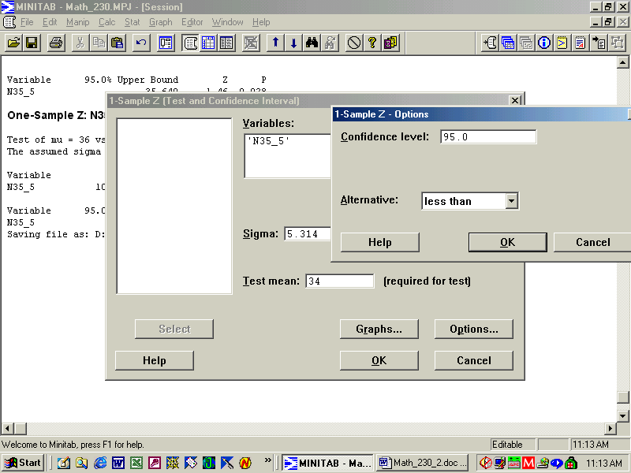

One-Sample Z: N35_5

Test of mu = 34 vs mu < 34
The assumed sigma = 5.314

Variable N Mean StDev SE Mean
N35_5 100 34.775 5.314 0.531

Variable 95.0% Upper Bound Z P
N35_5 35.649 1.46 0.928

Harper note: This is a one-tailed test with 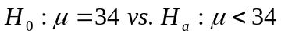. Thus all of alpha will be placed into one of the two tails of the normal distribution. Alpha = 0.05 since the confidence level is 95%. All of this 5% is placed in the tail that corresponds to the alternative hypothesis H_{a}. Since the alternative hypothesis is a < hypothesis, then all of alpha is placed in the lower tail of the normal, i.e., all 5% is placed in the lower tail. While we did not study one sided confidence intervals, the above 95% upper bound is really a 1 sided confidence interval saying that all values in the interval 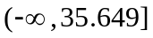are possible values for the population mean .

One-Sample Z: N35_5

Test of mu = 36 vs mu < 36
The assumed sigma = 5.314

Variable N Mean StDev SE Mean
N35_5 100 34.775 5.314 0.531

Variable 95.0% Upper Bound Z P
N35_5 35.649 -2.31 0.011

Harper note: What is alpha above? What is your decision on the above? What are the two hypotheses? Can you get the z value shown above? Can you see 3 ways to back up your conclusion?

Now let’s move this a Chapter 10 mode, i.e., small sample. We will stick with the same data as above even though the sample size n is not < 30. In practice anyway, you very, very, very seldom are willing to assume that you really know the population standard deviation sigma. So in Chapter 10 you explicitly use the sample standard deviation s and recognize that it is an estimate of sigma and not necessarily equal to the true sigma. In doing so, we use a t distribution (William Gosset in 1908 published this under the name “Student”) often called the “Student’s t distribution”. The same concepts as above apply but now we have a slighter wider distribution that depends on something called the degrees of freedom (df). Note that with df, the t table exactly matches the normal table.

Notice that the t distribution material below looks very similar to the earlier normal work, but notice that no sigma is asked for as it computes and uses the sample standard deviation s instead of sigma.

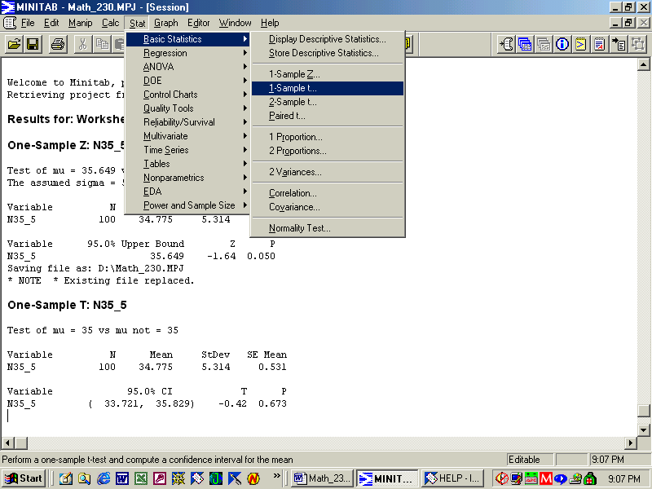
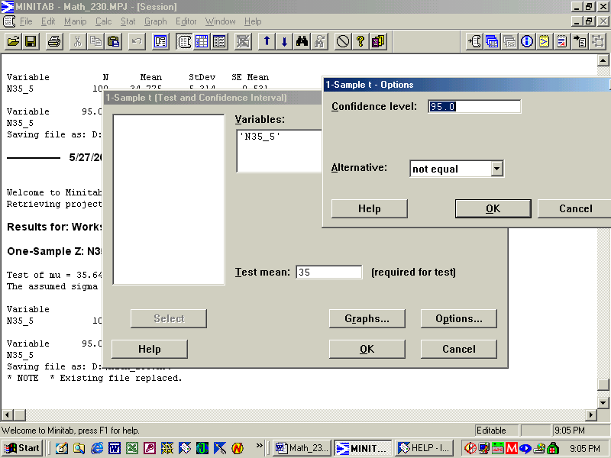

One-Sample T: N35_5 (Harper: this is a t-test!!!)
Test of mu = 35 vs mu not = 35
Variable N Mean StDev SE Mean
N35_5 100 34.775 5.314 0.531

Variable 95.0% CI T P
N35_5 ( 33.721, 35.829) -0.42 0.673

Harper note: Note the similarity between this t-test for a single population mean and the earlier z-test result. The confidence interval above is slightly wider than the earlier one. As the sample size n gets smaller, you will notice larger differences, but the concepts are basically the same. The degrees of freedom are n-1 for a one-sample test on a population mean. For a two-sample test with n₁ and n₂ observations from each population, the df = n₁ + n₂ – 2. Can you get the same t value as above, the same CI?

Harper note: The above dealt with a single mean. What about a single proportion? As it turns out, only the z test is appropriate for a proportion. Actually Minitab computes an exact confidence interval while our z test approach is a large sample approximation. We can tell Minitab to do the z test just to match our book, but in practice go with the default proportion test that is more accurate.

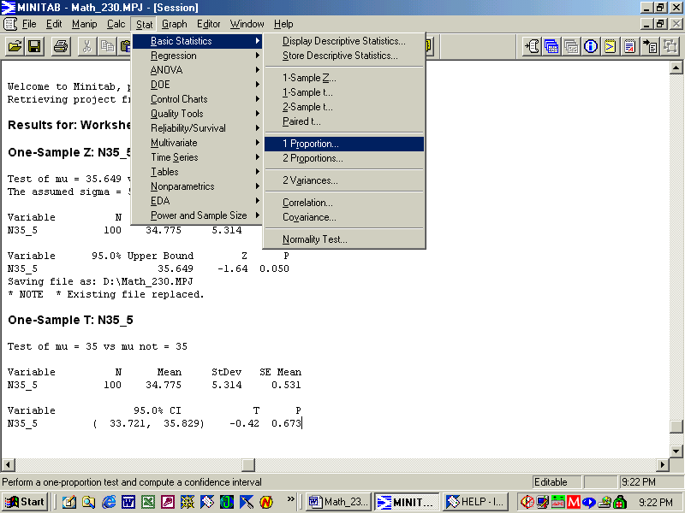

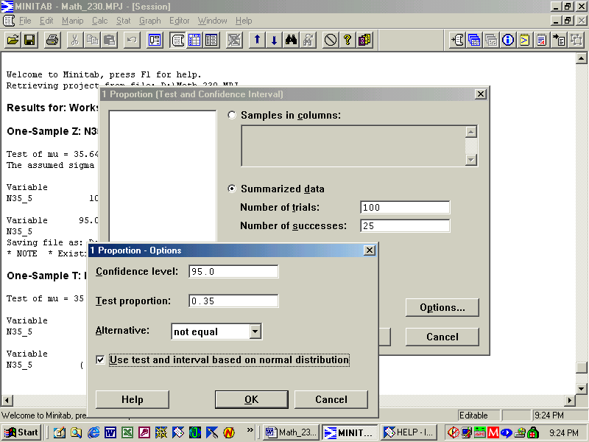

Harper note: Note that I clicked on the normal distribution option to match book’s answers.

Test and CI for One Proportion

Test of p = 0.35 vs p not = 0.35

Sample X N Sample p 95.0% CI Z-Value P-Value
1 25 100 0.250000 (0.165131, 0.334869) -2.10 0.036

Harper note: What is the hypothesis being tested? What is your decision (based on 3 different criteria)? Can you manually generate the same results above?

OK basic concepts from before also apply to tests for proportions.

What about two sample tests in which two means are compared to each other? Or two proportions are compared to each other? For both of these, you do not need to know how to do the manual calculations, but you must be able to interpret the Minitab output.

Let’s look at the two sample proportion.

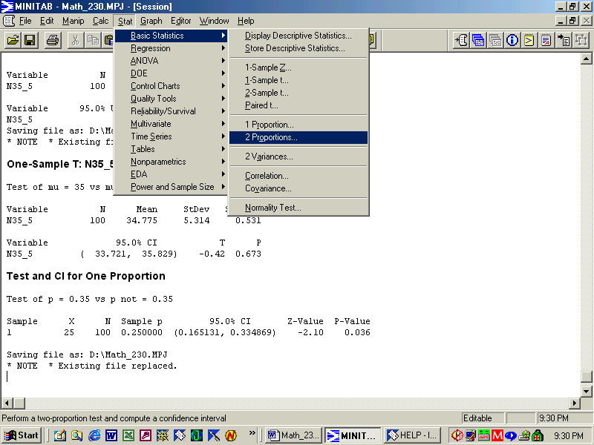

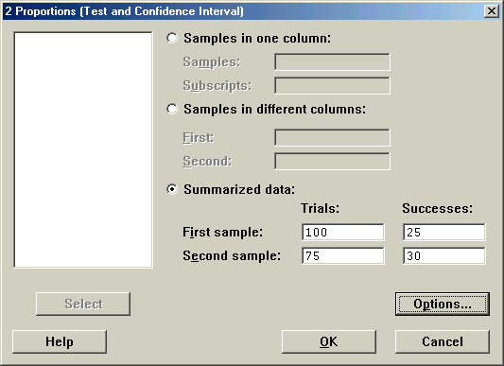

Test and CI for Two Proportions

Sample X N Sample p
1 25 100 0.250000
2 30 75 0.400000

Estimate for p(1) - p(2): -0.15
95% CI for p(1) - p(2): (-0.289626, -0.0103741)
Test for p(1) - p(2) = 0 (vs not = 0): Z = -2.11 P-Value = 0.035

The confidence interval above is for the difference between the two proportions. If 0.0 falls into the interval, then there is no statistically significant difference between the two proportions at the specified alpha level 0.05 (since it’s a 95% CI). Since the abs(-2.11) > 1.96 (critical z value for a two-tailed 95% hypothesis test), Reject Ho that that the two proportions are equal. For all two sample problems and more than two sample ANOVA problems seen later in the quarter, we will only look at two-sided (or two-tailed) tests. BTW, abs is absolute value.

OK, another deal for you. Since in practice you will not do a z test for either one mean or the difference in two means but will instead do a t-test, you will only be tested on the two sample t-test for the difference in two population means.

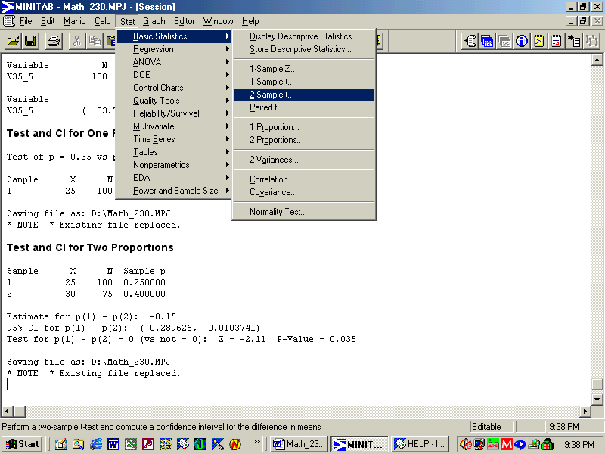

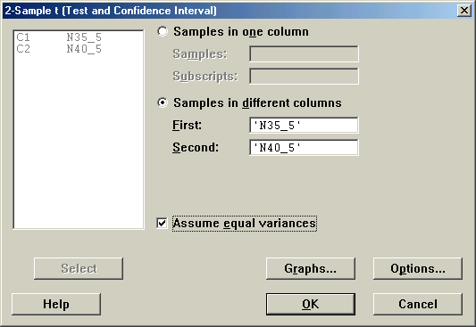

You have to click the “Assume equal variances”; otherwise, your answer will not match the book. The book (as do other intro books) shows older and easier ways to calculate some things that can be done manually w/o a computer.

Two-Sample T-Test and CI: N35_5, N40_5
Two-sample T for N35_5 vs N40_5

N Mean StDev SE Mean
N35_5 100 34.77 5.31 0.53
N40_5 100 39.94 4.98 0.50

Difference = mu N35_5 - mu N40_5
Estimate for difference: -5.165
95% CI for difference: (-6.601, -3.729)
T-Test of difference = 0 (vs not =): T-Value = -7.09 P-Value = 0.000 DF = 198
Both use Pooled StDev = 5.15

Harper note: What is being tested above? What are the two hypotheses? What is your decision (based on 3 different criteria).

I hope the above is helpful. You can use it on the final. I will edit the Minitab output to give you only a subset of the information you see above. My rationale is that I want you to be able to determine the correct answer from any of the 3 criteria. So make sure you understand all 3 and do not count on just one of them.

Chapter 11: just a very small subset. If you take more stats in the future, you will likely get lots more of ANOVA (analysis of variance).

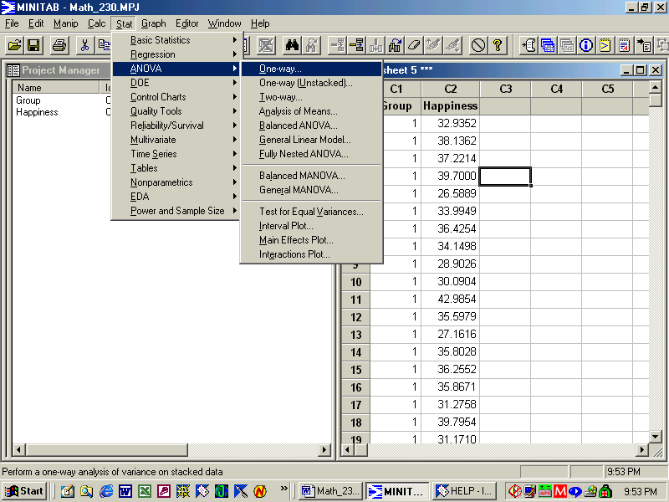
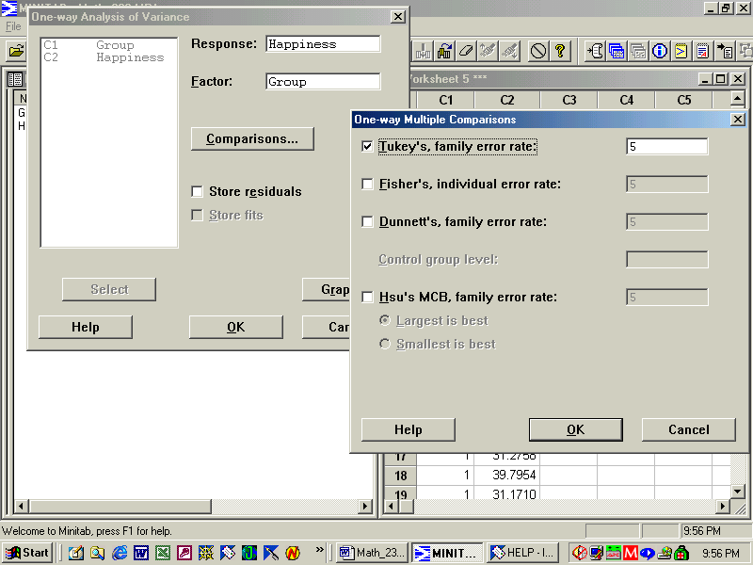

Harper note: Notice that the alpha level is specified above (instead of the confidence level). In this case, alpha = 5%. I am just showing a subset of the Minitab printout below. We are comparing 3 groups on “Happiness”. Minitab often truncates variable names to 8 characters in various printouts. If the p-value is < alpha, then look at the multiple comparisons; otherwise declare all means to be equal.

One-way ANOVA: Happiness versus Group

Analysis of Variance for Happines
Source DF SS MS F P
Group 2 630.3 315.1 12.27 0.000
Error 297 7631.1 25.7
Total 299 8261.3

Tukey's pairwise comparisons (Harper note: this is one form of a multiple comparison)
Intervals for (column level mean) - (row level mean)

1 2

2 -4.398
-1.043

3 -5.014 -2.293
-1.658 1.062
Harper note: If the interval does not include 0.0 then the two means are significantly different at the alpha level specified. Thus mean 1 is significantly different than mean 2 and also from mean 3. However, mean 2 and mean 3 are not significantly different since the confidence interval for their difference includes 0.0 (-2.293, 1.062).

Chapter 12: Linear Regression and correlation analysis. Once again, this is a very brief introduction to an important statistical area.

Results for: Cereal.MTW

Correlations: Protein, Carbo, Fat, Calories, VitaminA

Protein Carbo Fat Calories
Carbo -0.168
0.602

Fat 0.412 0.047
0.183 0.885

Calories 0.341 0.838 0.311
0.277 0.001 0.326

VitaminA -0.142 0.300 0.094 0.313
0.661 0.343 0.770 0.322

Cell Contents: Pearson correlation
P-Value

Using an alpha level = 0.05, only one of the above pairs are significantly correlated (carbo, calories). The top number is the correlation coefficient (0.838 for carbo, calories) and the bottom number is the level of significance or p-value (0.001 for carbo, calories). Correlation is a measure of the linear relationship between two variables and can vary from –1 (perfect negative correlation) to +1 (perfect positive correlation). The hypothesis being tested above is whether the correlation is 0.0 implying that the two variables are not related. Rejection of this null hypothesis implies there is some relationship. Extreme care is needed with correlations as there exists a high chance for statistical abuse and just plain garbage.

Regression Analysis: Calories versus Carbo
The regression equation is
Calories = 18.0814 + 3.77907 Carbo

S = 10.2157 R-Sq = 70.2 % R-Sq(adj) = 67.2 %

Analysis of Variance

Source DF SS MS F P
Regression 1 2456.40 2456.40 23.5376 0.001
Error 10 1043.60 104.36
Total 11 3500.00

Harper note: The above regression is statistically significant since the p-value is 0.001 (assuming alpha = 0.05). Note the prediction equation is also given above so that one could put in a carbo value and predict calories. Care must be taken to stay within the range of the original carbo values; otherwise, you are extrapolating beyond the range used to develop the above relationship.

