**INST 2403 STUDY GUIDE for Midterm 1 FALL 2017**

**Form of Exam**

* About 35 questions
* Mostly multiple choice
* Few short answer question
* You have the whole class period; this should be ample time
* Scantron sheets are used

**Topics** (also see syllabus)

* Patterns in the sky, Constellations
* Daily Motion
* Seasonal Motion
* Seasons
* Moon motion and Moon Phases, Eclipses
* Motion of the Planets in the sky (not in orbit, i.e. no Kepler, Copernicus, Ptolemy)

**Suggestions**

* Review textbook readings, online Powerpoint slides
* Look over the activities
* Take another look at the homework questions. In particular, take a look at the solutions after you committed to an answer
* It might help to go to the library and study other astronomy texts. Often reading an independent explanation in slightly different wording helps to understand a complex concept.

**General Questions to ponder in preparation for the exam**

* How do objects move across the sky: in a day, during a year?
* How/Why are the motions of the sun/moon/planets different from that of the stars?
* Operational definition of noon, midnight, south, north, ecliptic, sidereal & solar day.
* How does the time/date/position on earth influence what you see in the sky?
* How does the moon change its appearance/position relative to sun and earth?
* What are the reasons for the seasons? Which are not reasons for the seasons?
* How does the view of the sky change if observed 2 hours earlier/later? Two months/weeks earlier/later?

**Sample Questions**

1. It is last quarter moon. In three days, what will the phase of the moon be?

1. Last Quarter Moon
2. Waxing Gibbous
3. Waning Gibbous
4. New Moon
5. Waning Crescent

2. A star is in its highest position in the south at midnight. Two months earlier it was at this position around …

1. midnight
2. 10 pm
3. 8 pm
4. 2 am
5. 4 am

3. When the Moon is new, which of the following drawings best represents the relative positions of Sun (S), Moon (M), and Earth (E)?

a) S-------M----E b) S------E----M c) M---S--E

d) S e) S

| |

| |

E----M M---E

4. On December 1, at noon, you are looking toward the south and see the Sun among the stars of the constellation Scorpius as shown in Figure 1. One month later at noon, where will the Sun be with respect to the stars shown in this diagram?

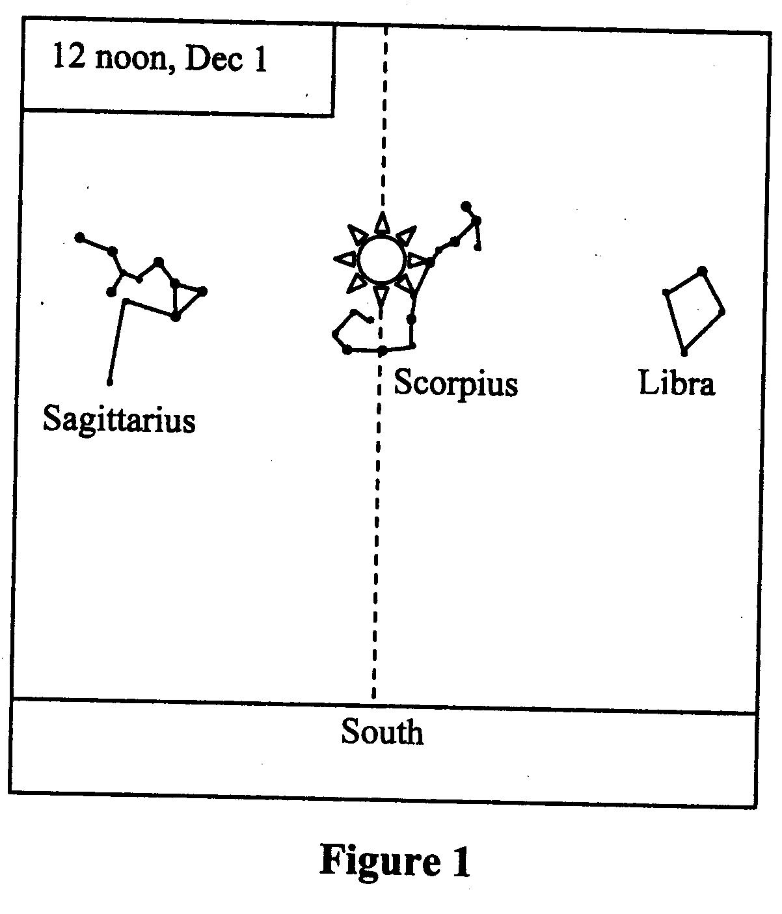

* 1. in the constellation Sagittarius
  2. in the constellation Scorpius
  3. in the constellation Libra
  4. west (right) of Libra
  5. east (left) of Sagittarius

5. Anti-Westerville is located at 40 degrees southern latitude. For an observer in Anti-Westerville, what is the maximal altitude above the horizon of a point on the Celestial Equator?

* 1. 40 degrees
  2. 50 degrees
  3. 90 degrees
  4. – 40 degrees
  5. – 50 degrees

6. The waning gibbous moon and the sun are separated by an angle of about 225 degrees in the sky, as we are seeing more than half of the moon lit up by the sun. In which direction do you have to look to see the waxing gibbous moon when it is at its highest daily altitude above the horizon?

1. North
2. West
3. South
4. None of the above

7. You see two objects in the sky. One appears to be bigger. Which is a correct statement?

1. If one object appears bigger than the other, it also has to be closer than the other object.
2. The object appearing smaller is actually smaller.
3. The ratio of diameter to distance is the same for both of them
4. The bigger object could be actually smaller.
5. None of the above

8. To see a constellation at a particular position in the sky, you need to know date and time. As an example, say we are seeing Gemini in the south at 10pm on February 1. At what other combination of date and time do we see Gemini in the south?

1. December 1 at 2 am
2. November 1 at 10pm
3. January 1 at 6pm
4. December 15 at 11pm
5. None of the above

9. (Short Answer) How does the observer’s position on the Earth affect his or her view of the night sky? In particular, how does the view change if the position is shifted further East and South?

10. (Short answer) Explain why the retrograde motion of a planet in the sky is strange, especially when compared with the motion of the sun and the moon.