**INST 2403 Solutions to STUDY GUIDE for Midterm 2 FALL 2017**

**Sample Questions**

1. How would the strength of the force between Saturn and the Sun change if Saturn were ten times closer to the Sun?
   1. It would not change.
   2. It would be ten times as large.
   3. It would be ten times smaller
   4. It would be 29 times larger.
   5. It would be one hundred times larger. (CORRECT)
2. The mass of the Moon is 80 times smaller than that of Earth. How does the strength of the gravitational force that the Earth exerts on the Moon compare to the gravitational force that the Moon exerts on Earth?

a) It is 80 times smaller.

b) It is 80 times bigger.

c) It is 6400 times smaller.

d) None of the above. (CORRECT)

1. Approximately how long is a Saturn year, i.e. the time that it takes Saturn to orbit once around the sun? *(Hint: Saturn is 9.5 AU away from the sun, and Kepler’s 3rd law states that P2/a3=1.)* 
   1. 2 years
   2. 5 years
   3. 12 years
   4. 29 years (CORRECT)
   5. 84 years

4. Compare the power radiated by two stars A & B. The temperatures of the stars are related: TB = 3 TA. How do the power outputs P of the stars compare?

a. PA = PB

b. PA = 1/216 PB

c. PB = 81 PA (CORRECT)

d. PB = 3 x 104 PA

e. None of the above.

5. Consider the two blackbody spectra shown in Figure 2a, where the energy output per second is plotted as a function of the wavelength. The colors in the visible range are represented by their first letter (v=violet, r=red, etc.) What can we conclude about the properties of stars A and star B?

1. Star A has a smaller peak frequency than star B.
2. Star A has a longer peak wavelength than star B.
3. Star A is cooler than star B.
4. Star A radiates more red light than star B. (CORRECT)
5. Star A and star B have the same temperature.

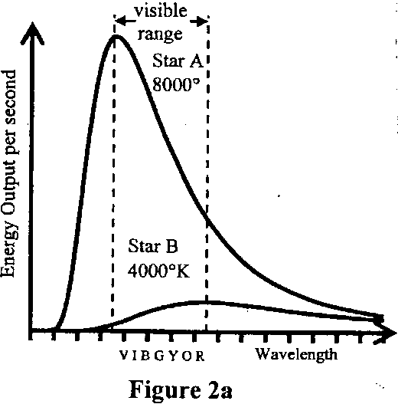

6. How did Maskelyne “weigh” the Earth?

1. By scaling up the mass of a mountain to the volume of the Earth
2. By comparing the attraction of a plumb line to a mountain to its attraction to Earth (CORRECT)
3. By relating the density of granite to the known density of Earth.
4. None of the above

7. The peak frequency of an object A’s blackbody curve is half as large as the one of B’s curve, hence

a. TA=TB

b. 2TA=TB (CORRECT)

c. TA=2TB

d. 4TA=16TB

8. A cold, low density cloud of gas put in front of a light bulb will produce what type of spectrum?

a) Continuous spectrum

b) Emission spectrum

c) Absorption spectrum (CORRECT)

d) No spectrum

e) Kirchhoff spectrum

1. What causes stellar aberration?
2. It is caused by the proper motion of the stars. Stars are not completely fixed with respect to each other, but over long periods they move with respect to each other.
3. It is caused by the motion of the observer on Earth. Due to the orbital motion of the Earth, we change our vantage point. Therefore a star appears in front of a different background, i.e. its position changes.
4. It is caused by the finite speed of light. The aberration constant (angle, size of the effect) is the ratio of the speed of the observer (i.e. Earth's orbital speed) and the speed of light. (CORRECT)
5. None of the other descriptions is correct.

10. *Saving the appearances* is a key phrase in the development of the theory of planetary motions. What is it, exactly?

* 1. You want to appear to be doing serious astronomical work, even though you have only weak arguments for your theory
  2. A theory is said to save the appearances when it is bogus but uses the right buzz words
  3. The minimal job description of a planetary theory is that it reproduces the positions of planets, sun & moon in the sky, ie. their appearances. (CORRECT)
  4. None of the above

11. What is the main purpose of a telescope?

1. To magnify objects as much as possible.
2. To collect light/information. (CORRECT)
3. To point accurately to a specific position in the sky.
4. None of the above

12. Compare UV light with radio waves. Which of the following statements is true?

a. UV light is faster.

b. UV light is more energetic. (CORRECT)

c. UV light has a longer wavelength.

d. UV light has a lower frequency.

e. None of the above

**Short Answer Questions**

13. Explain Kepler’s second law in your own words. (Merely restating it won’t garner any points.)

Kepler’s second law describes how the planets move around the sun along their elliptical orbits. They are faster when they are closer to the sun, and slower when they are farther away. Quantitatively, this is realized by the prescription that the line planet-sun sweeps out equal areas in equal time, so that more way along the orbit has to be made by the planet when it is close to the sun, since one side of the triangle or other shape used to compute the area is smaller.

14. Why do the planets have (almost) circular orbits around the Sun, even though the gravitational force of the Sun points exactly at the Sun, i.e. works to pull the planets closer to the Sun? Argue with Newton’s laws.

The planets have their inertia; according to Newton’s first law they have the tendency to move in straight lines, tangential to their curved orbits. The sun’s gravitational pull changes this direction of motion, and the “compromise” path is the near-circular orbit of the planet.

15. How did Galileo’s observation of the phases of Venus enable him to rule out the geocentric theory?

Ptolemy’s geocentric theory predicts that Venus phases should be new or crescent, but never full, gibbous or half. Observing the latter three phases, Galileo could rule out or falsify the geocentric model.