**INST 2403 Solutions to STUDY GUIDE for Midterm 1 FALL 2017**

1. It is last quarter moon. In three days, what will the phase of the moon be?

1. Last Quarter Moon
2. Waxing Gibbous
3. Waning Gibbous
4. New Moon
5. Waning Crescent (CORRECT)

2. A star is in its highest position in the south at midnight. Two months earlier it was at this position around …

1. midnight
2. 10 pm
3. 8 pm
4. 2 am
5. 4 am (CORRECT)

3. When the Moon is new, which of the following drawings best represents the relative positions of Sun (S), Moon (M), and Earth (E)?

a) S-------M----E (CORRECT) b) S------E----M c) M---S--E

d) S e) S

| |

| |

E----M M---E

4. On December 1, at noon, you are looking toward the south and see the Sun among the stars of the constellation Scorpius as shown in Figure 1. One month later at noon, where will the Sun be with respect to the stars shown in this diagram?

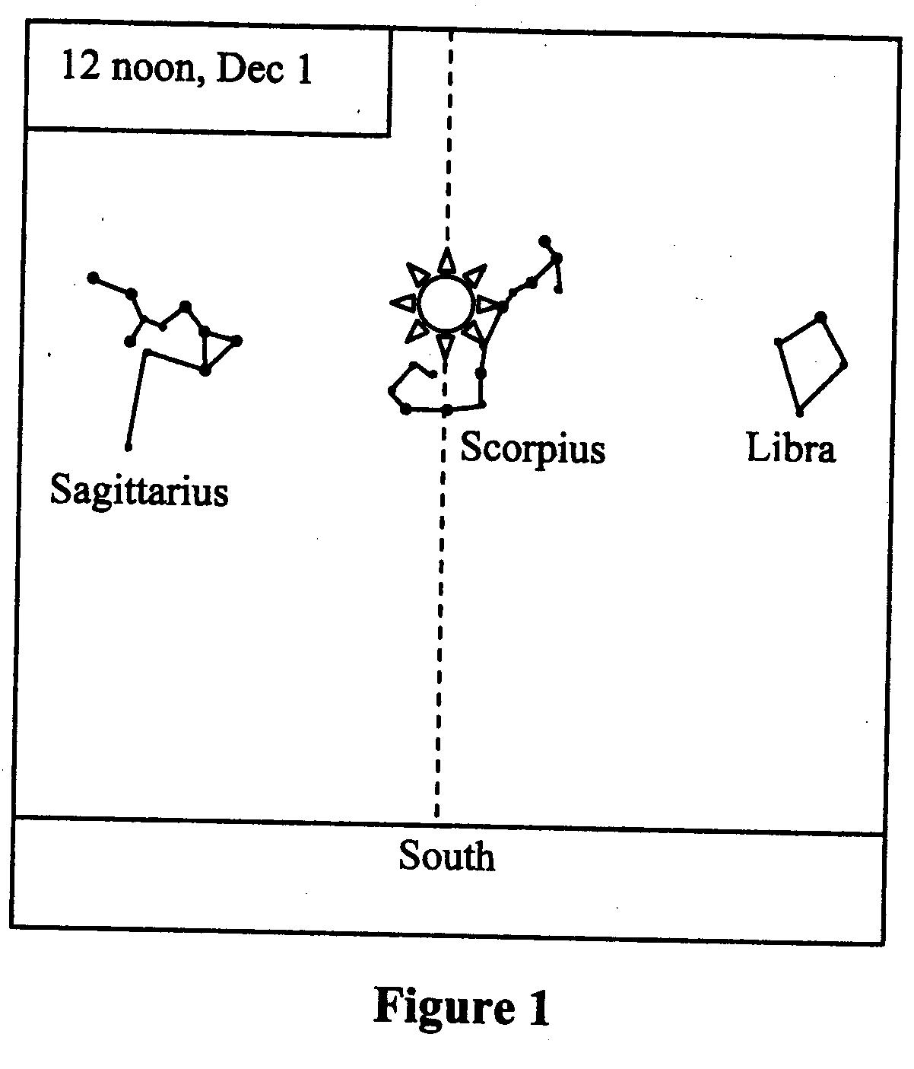

* 1. in the constellation Sagittarius (CORRECT)
  2. in the constellation Scorpius
  3. in the constellation Libra
  4. west (right) of Libra
  5. east (left) of Sagittarius

5. Anti-Westerville is located at 40 degrees southern latitude. For an observer in Anti-Westerville, what is the maximal altitude above the horizon of a point on the Celestial Equator?

* 1. 40 degrees
  2. 50 degrees (CORRECT)
  3. 90 degrees
  4. – 40 degrees
  5. – 50 degrees

6. The waning gibbous moon and the sun are separated by an angle of about 225 degrees in the sky, as we are seeing more than half of the moon lit up by the sun. In which direction do you have to look to see the waxing gibbous moon when it is at its highest daily altitude above the horizon?

1. North
2. West
3. South (CORRECT)
4. None of the above

7. You see two objects in the sky. One appears to be bigger. Which is a correct statement?

1. If one object appears bigger than the other, it also has to be closer than the other object.
2. The object appearing smaller is actually smaller.
3. The ratio of diameter to distance is the same for both of them
4. The bigger object could be actually smaller. (CORRECT)
5. None of the above

8. To see a constellation at a particular position in the sky, you need to know date and time. As an example, say we are seeing Gemini in the south at 10pm on February 1. At what other combination of date and time do we see Gemini in the south?

1. December 1 at 2 am (CORRECT)
2. November 1 at 10pm
3. January 1 at 6pm
4. December 15 at 11pm
5. None of the above

9. (Short Answer) How does the observer’s position on the Earth affect his or her view of the night sky? In particular, how does the view change if the position is shifted further east and south? The further south you go the lower the CNP (and the higher the CSP). The altitude angle of the celestial pole is your latitude. The further east you go the later it is, i.e. the sky further is “turned” further west by 1 degree for each degree longitude you are further east.

10. (Short answer) Explain why the retrograde motion of a planet in the sky is strange, especially when compared with the motion of the sun and the moon.

Sun and moon move along their paths in the sky unidirectionally. They never slow to a halt or turn around. The planets exhibit apparent motion both in celestial latitude and longitude, which results in the retrograde loops.