# Name:__________________________________ Test Form **B**

## INST 2403

## The Expanding Universe

## First Exam

## September 15, 2017

# Instructions

1. Use a number 2 pencil.
2. **Important:** Write your name on the computer form and fill in the appropriate circles. Bubble in your **student ID (or any other number)**. Bubble in **B** in the **Test Form** field.
3. Select only the best answer to each question; multiple answers will be marked wrong. No points are taken off for wrong answers, so it is to your advantage to guess if you are unsure of the answer.
4. Mark your answers on the computer form. You may write in the exam booklet if you wish, but only the computer form will be graded.
5. You must **sign** and **return this exam booklet** in order to receive credit for the exam!
6. You will have a maximum of **70 Minutes** to complete the exam.
7. This exam contains **35 questions**.
8. Use the backside of the computer form to record the answers to the **last three questions,** which are **not** multiple-choice but short answer questions.
9. You should be able to answer all questions without using a calculator, but if you wish, you can use a scientific calculator.

1. Night and day have approximately equal length at what time or times during the year?

a) winter solstice

b) vernal and autumnal equinoxes

c) summer and winter equinoxes

d) summer solstice

1. During the course of a single night, a planet in prograde motion will ...
   1. ... do what the stars do
   2. ... loop around in the sky
   3. ... none of the other things
   4. ... shift westward with respect to the stars
   5. ... rise in the west and sink in the east
2. Noticing the relative position of Sun, Earth and Moon during New Moon, when does the New Moon rise?
   1. Sunrise
   2. Sunset
   3. Noon
   4. Midnight
   5. None of the above
3. Look at the figure of the zodiac below. Shown is the position of the Earth on December 1. The Earth rotates counterclockwise around the sun. In which zodiac constellation can the sun be found on February 1?

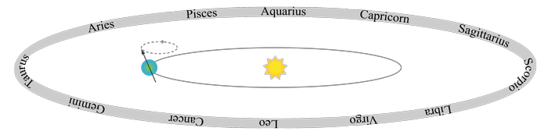

* 1. Cancer
  2. Virgo
  3. Scorpio
  4. Capricorn
  5. None of the above.

1. Look at the figure of the zodiac above and refer to the last question. On February 1, which constellation can be seen well in the night sky, i.e. which zodiac constellation culminates at midnight?
   1. Cancer
   2. Virgo
   3. Scorpio
   4. Capricorn
   5. None of the above.

6. It is noon in Westerville. What is the time in London, UK?

a) Noon

b) Earlier, same day

c) Later, same day

d) Noon, the next day.

e) Noon, the previous day.

7. It is full moon. In three days, what will the phase of the moon be?

1. Last Quarter Moon
2. Waxing Gibbous
3. Waning Gibbous
4. New Moon
5. Waning Crescent

8. You are stranded on a desert island. On a clear night, you try to locate Polaris, but you are unable to do so. What can you conclude?

1. You are at the south pole.
2. You are in the southern hemisphere.
3. It is summer.
4. It is winter.
5. You are at 23 ½ degrees northern latitude.

9. On December 1, at noon, you are looking toward the south and see the Sun among the stars of the constellation Scorpius as shown in Figure 1. At 4 PM that afternoon, where will the Sun be with respect to the stars shown in this diagram?

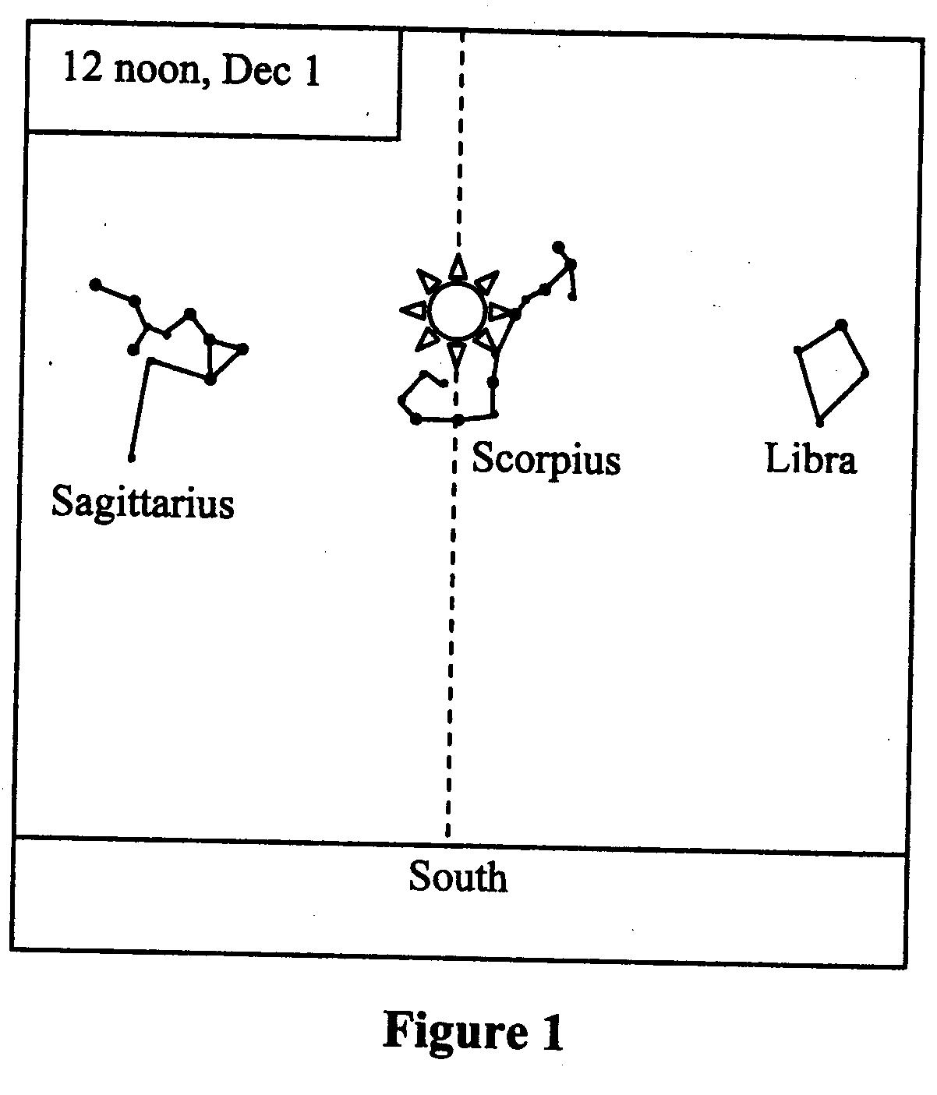

* 1. in the constellation Sagittarius
  2. in the constellation Scorpius
  3. in the constellation Libra
  4. west (right) of Libra
  5. east (left) of Sagittarius

10. On December 1, at noon, you are looking toward the south and see the Sun among the stars of the constellation Scorpius as shown in Figure 1. One month earlier at noon, where was the Sun with respect to the stars shown in this diagram?

* 1. in the constellation Sagittarius
  2. in the constellation Scorpius
  3. in the constellation Libra
  4. west (right) of Libra
  5. east (left) of Sagittarius

11. If the Moon would orbit the Earth in the plane of the Earth’s orbit around the sun, how many **lunar** eclipses would you expect?

1. 2, one each half year
2. 12, one each month
3. 26, one every two weeks
4. 52, one every week

12. If the Moon was full when it was rising above the horizon, what phase will it be in when it sets?

a) New Moon

b) First Quarter

c) Waxing Gibbous

d) Last Quarter

e) Full Moon

13. Why isn’t there a solar eclipse every new moon?

a) The Moon’s orbit has no eccentricity.

b) Sometimes the moon’s apparent size is not big enough to hide the Sun.

c) The shadow of the Earth might not be long enough to reach the Moon.

d) The Moon’s orbit is inclined with respect to the Earth’s orbit around the Sun.

e) None of the above.

14. When the Moon is full, which of the following drawings best represents the relative positions of Sun (S), Moon (M), and Earth (E)?

a) S-------M----E b) S------E----M c) M---S--E

d) S e) S

| |

| |

E----M M---E

15. Which of the following is explained by the rotation of the Earth around its axis?

a) Mars occasionally exhibits retrograde motion.

b) When it is summer in the northern hemisphere, it is winter in the southern hemisphere.

c) The orbit of the Earth is an ellipse, not a circle.

d) The Sun, the Moon, and most of the stars rise in the east and set in the west.

e) The phases of Venus

16. The ecliptic is

a) the day of the year when daylight is longest.

b) the apparent path of the Sun through the stars in the sky.

c) the dark inner shadow of a solar eclipse.

d) the astrological term for when Jupiter aligns with Mars.

e) the scientific name for the celestial equator.

17. What is NOT a consequence of the fact that the Earth’s equator is tilted with respect to the plane of its orbit around the Sun?

a) We experience seasons on Earth.

b) Days and nights are typically of different length.

c) At noon, the Sun appears at different heights in the sky in different months.

d) There is a non-zero angle between the celestial equator and the ecliptic.

e) The Sun, the Moon and the stars rise in the East.

18. Figure 2 shows a horizon view of what you would see when facing south at midnight on the night of December 1 in the northern hemisphere. How would this view change if you were to look towards south at midnight a month earlier?

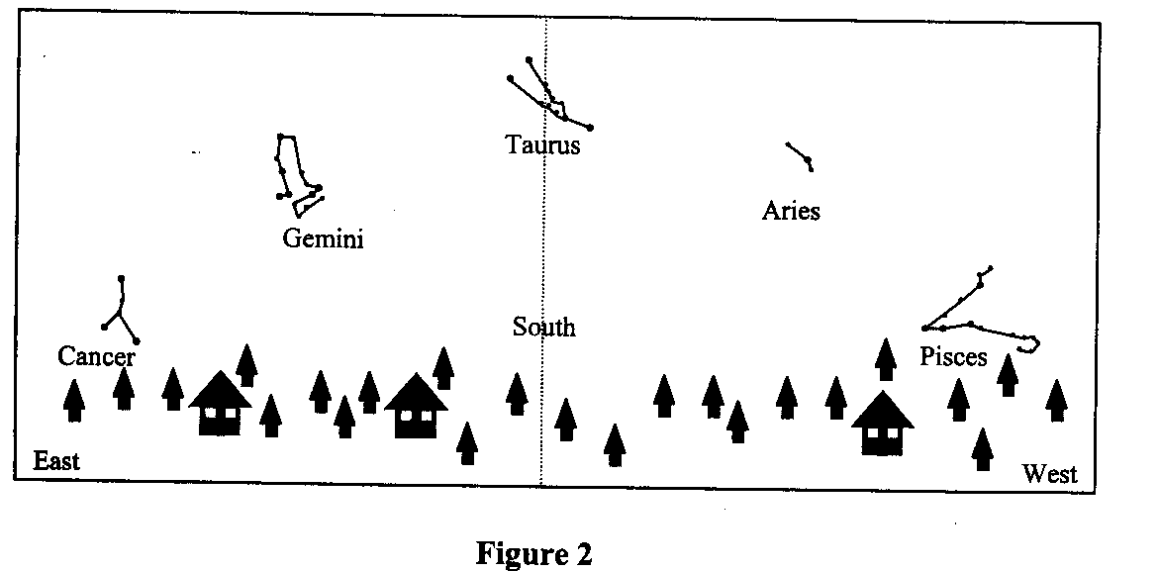

a. You would have the same view as on December 1 because it still is autumn.

b. Aries would have been in the South because the stars rise earlier in the East every day.

c. Cancer would be in the South because the seasons were closer to summer.

d. Gemini would have been highest in the South because the stars set earlier in the West.

e. Pisces would have been highest in the South because the Sun has moved a lot with respect to the stars in one month.

19. Consider Figure 2 again. How would this view change if you were to look towards south at 2am, i.e. two hours later?

a. You would have the same view since the Earth barely moves around the Sun in two hours.

b. Aries would be in the South because the stars shift by one constellation.

c. Pisces would be in the South because the stars shift a constellation per hour.

d. Gemini would be highest in the South because the Earth rotates 30 degrees in 2 hours.

e. Cancer would be highest in the South because the stars drift westward.

1. The sidereal day (a full rotation of the Earth measured relative to distant stars) is 4 minutes SHORTER than a solar day. If the Earth's spin were in the opposite direction then a sidereal day would ...
   1. change, but remain shorter than a solar day.
   2. be longer than a solar day.
   3. not change.
   4. be the same as a solar day.
2. Westerville is located at 40 degrees northern latitude. If you are observing from Westerville, which is NOT a correct statement?
   1. Some stars never rise or set.
   2. You can see stars of the southern sky up to declination –50 degrees
   3. The Celestial Equator is 40 degrees off the Celestial North Pole.
   4. The ecliptic is inclined 23.5 degrees with respect to the Celestial equator.
   5. All are correct.

22. A lunar eclipse can only happen at the time of a _______ moon.

a) new

b) gibbous

c) crescent

d) full

e) half

1. A planet in retrograde motion...
   1. will be exactly overhead no matter where you are on earth.
   2. shifts westward with respect to the stars.
   3. will be visible only on the southern hemisphere.
   4. rises in the west and sets in the east.
   5. will be at the north celestial pole.
2. Hawaii is located at 20 degrees northern latitude. For an observer in Hawaii, what is the maximal altitude above the horizon of a point on the Celestial Equator?
   1. 20 degrees
   2. 50 degrees
   3. 70 degrees
   4. – 20 degrees
   5. – 50 degrees
3. The waxing gibbous moon and the sun are separated by an angle of about 135 degrees in the sky, as we are seeing more than half of the moon lit up by the sun. When is the waxing gibbous moon at its highest, daily altitude above the horizon?
   1. between 6pm and midnight
   2. 6am
   3. Noon
   4. 6pm
   5. between 6am and noon
4. The waxing gibbous moon and the sun are separated by an angle of about 135 degrees in the sky, as we are seeing more than half of the moon lit up by the sun. In which direction do you have to look to see the waxing gibbous moon when it is at its highest daily altitude above the horizon?
   1. North
   2. West
   3. South
   4. None of the above
5. To see the greatest number of stars possible throughout the period of one year, a person should be located at latitude
   1. 23.5 degrees
   2. 0 degrees.
   3. anywhere, since latitude makes no difference.
   4. 66.5 degrees
   5. 90 degrees.
6. Two objects appear to be the same size in the sky. This means that ...
   1. ... if one object is bigger than the other, it also has to be closer than the other object
   2. ... they are at the same distance from the observer
   3. ... the ratio of diameter to distance is the same for both of them
   4. ... they have the same diameter
   5. None of the above
7. You are observing the sky from longitude 145W. Where in the sky do you find Polaris?
   1. Halfway up
   2. Not enough information
   3. In the South
   4. Polaris is not visible
   5. In the North
8. Westerville is located at 40 degrees northern latitude. For an observer in Westerville, what is the maximal possible altitude of the sun above the horizon at noon?
   1. 23.5 degrees
   2. 66.5 degrees.
   3. 73.5 degrees
   4. 90 degrees.
   5. None of the above.
9. A star is in its highest position in the south at midnight. Two weeks earlier it was at this position around …
10. midnight
11. 10 pm
12. 11 pm
13. 1 am
14. 2 am
15. To see a constellation at a particular position in the sky, you need to know date and time. As an example, say we are seeing Taurus in the south at midnight on December 1. At what other combination of date and time do we see Taurus in the south?
    1. January 1 at 2 am
    2. November 1 at 10pm
    3. February 1 at 6pm
    4. December 15 at 11pm
    5. None of the above

**Short Answer Questions [3 points each]**

***(Please use the back side of the computer sheet to record your answers)***

33. Explain (not just state!) the difference between a solar and a sidereal day.

34. State and explain the two main reasons for the seasons resulting from the axis tilt of the Earth.

35. Explain why during a day the Sun can be considered a fixed star, and how it moves with respect to the stars during longer periods of time.